1. **Create a new HDFS file structure data/dev/analysis in the HDFS home directory. Copy the covid-19 folder in to it**

hdfs dfs -mkdir -p data/dev/analysis

[mavricbdhoct02@ip-10-1-1-204 ~]$ hdfs dfs -put codid-19 data/dev/analysis

[mavricbdhoct02@ip-10-1-1-204 ~]$ hdfs dfs -ls data/dev/analysis/codid-19

Found 3 items

-rw-r--r-- 3 mavricbdhoct02 mavricbdhoct02 2878318 2023-10-27 06:37 data/dev/analysis/codid-19/Covid_patient_Apr19.csv

-rw-r--r-- 3 mavricbdhoct02 mavricbdhoct02 1576844 2023-10-27 06:37 data/dev/analysis/codid-19/Covid_patient_Apr26.csv

-rw-r--r-- 3 mavricbdhoct02 mavricbdhoct02 3642061 2023-10-27 06:37 data/dev/analysis/codid-19/covid-countries-aggregated.csv

[mavricbdhoct02@ip-10-1-1-204 ~]$

1. **Change the permission of Covid_patient_Apr26.csv file to have onlyread/write/execute for the owner/ group and read/write permission for others.**

hdfs dfs -chmod 776 data/dev/analysis/codid-19/Covid_patient_Apr26.csv

[mavricbdhoct02@ip-10-1-1-204 ~]$ hdfs dfs -chmod 776 data/dev/analysis/codid-19/Covid_patient_Apr26.csv

[mavricbdhoct02@ip-10-1-1-204 ~]$ hdfs dfs -ls data/dev/analysis/codid-19

Found 3 items

-rw-r--r-- 3 mavricbdhoct02 mavricbdhoct02 2878318 2023-10-27 06:37 data/dev/analysis/codid-19/Covid_patient_Apr19.csv

-rwxrwxrw- 3 mavricbdhoct02 mavricbdhoct02 1576844 2023-10-27 06:37 data/dev/analysis/codid-19/Covid_patient_Apr26.csv

-rw-r--r-- 3 mavricbdhoct02 mavricbdhoct02 3642061 2023-10-27 06:37 data/dev/analysis/codid-19/covid-countries-aggregated.csv

1. **Copy covid-19 folder in to another hdfs directory data/prod/analysis**

hdfs dfs -cp data/dev/analysis/codid-19 data/prod/analysis

[mavricbdhoct02@ip-10-1-1-204 ~]$ hdfs dfs -cp data/dev/analysis/codid-19 data/prod/analysis

[mavricbdhoct02@ip-10-1-1-204 ~]$ hdfs dfs -ls data/prod/analysis/codid-19

Found 3 items

-rw-r--r-- 3 mavricbdhoct02 mavricbdhoct02 2878318 2023-10-27 06:49 data/prod/analysis/codid-19/Covid_patient_Apr19.csv

-rw-r--r-- 3 mavricbdhoct02 mavricbdhoct02 1576844 2023-10-27 06:49 data/prod/analysis/codid-19/Covid_patient_Apr26.csv

-rw-r--r-- 3 mavricbdhoct02 mavricbdhoct02 3642061 2023-10-27 06:49 data/prod/analysis/codid-19/covid-countries-aggregated.csv

1. **Read the contents of the file Covid_patient_Apr19.csv and print the contents on the screen**

hdfs dfs -cat data/prod/analysis/codid-19/Covid_patient_Apr19.csv

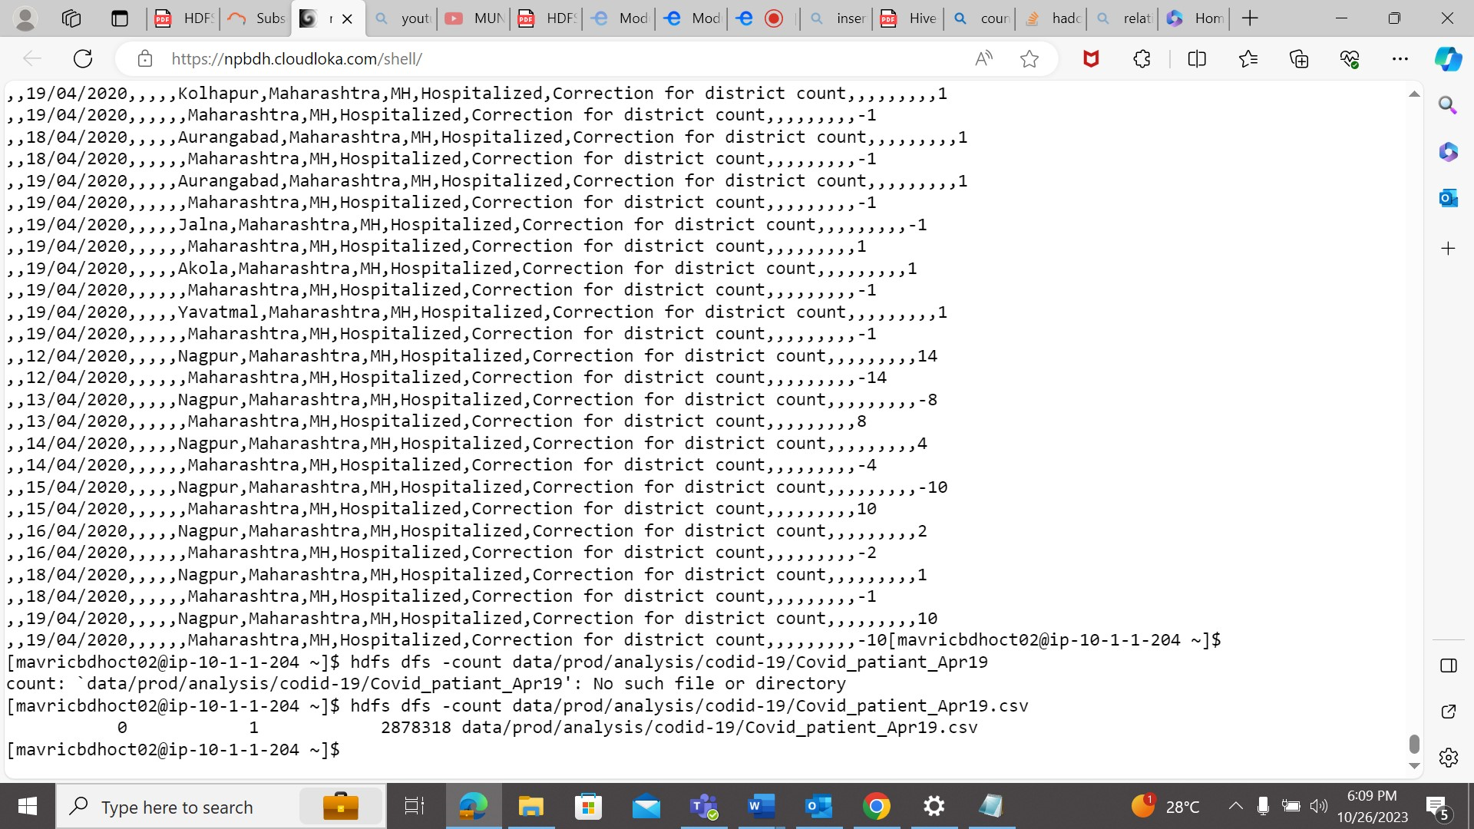

1. **Print the no of lines present in the HDFS file Covid_patient_Apr19.csv**

hdfs dfs -count data/prod/analysis/codid-19/Covid_patient_Apr19.csv

[mavricbdhoct02@ip-10-1-1-204 ~]$ hdfs dfs -count data/prod/analysis/codid-19/Covid_patient_Apr19.csv

1. 1 2878318 data/prod/analysis/codid-19/Covid_patient_Apr19.csv
2. **Count the no of records present in the HDFS file Covid_patient_Apr19.csv for the state “UP”**

hdfs dfs -cat data/prod/analysis/codid-19/Covid_patient_Apr19.csv | grep 'UP'

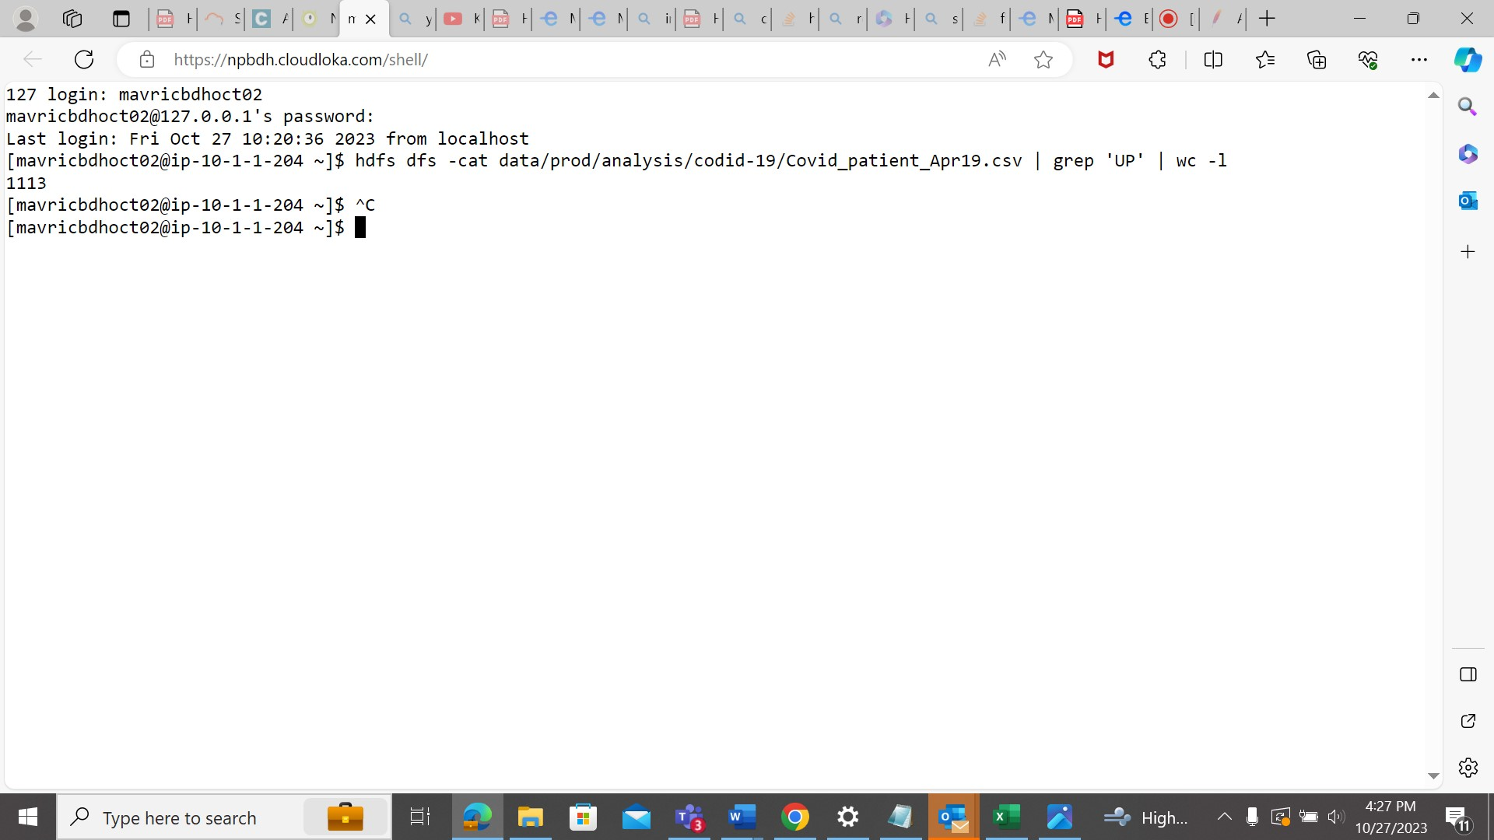



1. **Delete the file Covid_patient_Apr19.csv from the data/prod/analysis folder in HDFS**

hdfs dfs -rm data/prod/analysis/codid-19/Covid_patient_Apr19.csv

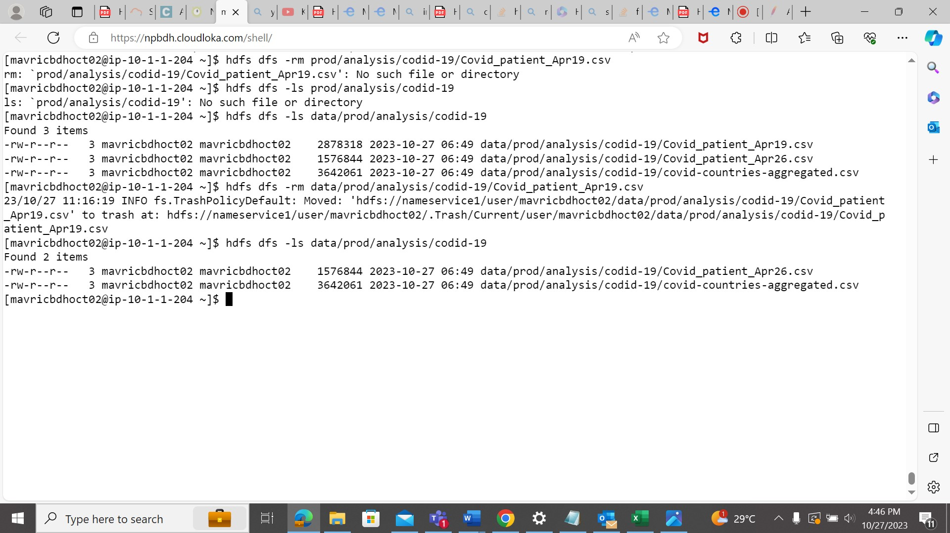

1. **Delete the covid-19 folder from both the dev and prod folders created above**

hdfs dfs -rm -r data/prod/analysis/codid-19 data/dev/analysis/codid-19

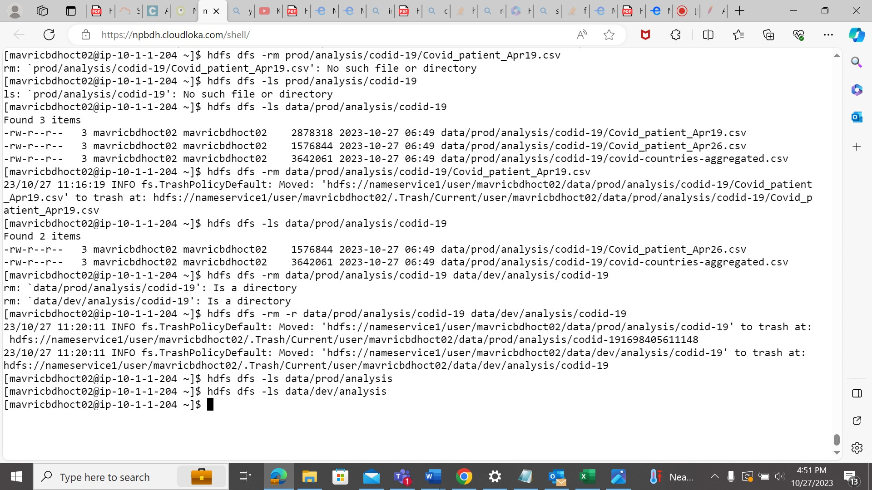

1. **Copy the tickitdb folder(in the local file system) in to HDFS home directory. How many blocks will be created for the files in this directory?**

hdfs dfs -put tickitdb /user/mavricbdhoct02

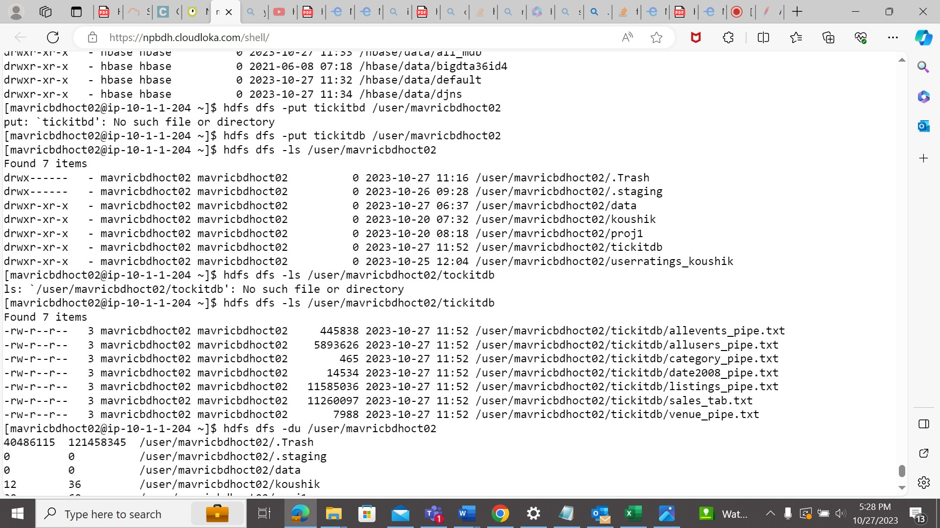

1. **Find all the file names which has the word “pipe” in their names**

hdfs dfs -ls /user/mavricbdhoct02/tickitdb | grep 'pipe'

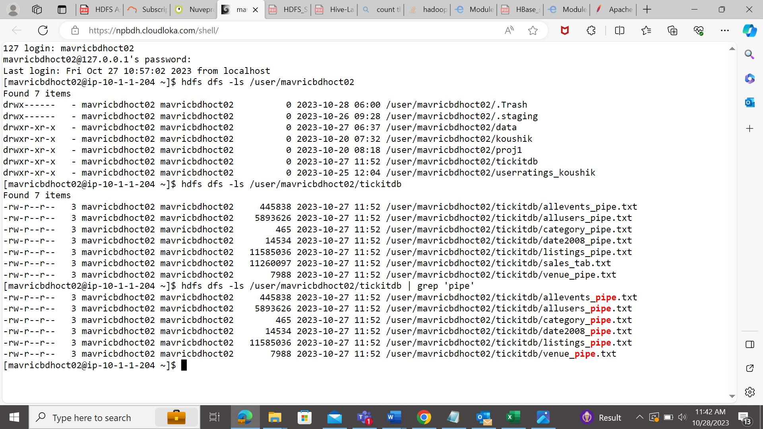

1. **Copy the h1b.csv file to hdfs home directory. How many blocks will be created for this file?**

hdfs fsck /user/mavricbdhoct02/h1b.csv -blocks

hdfs dfs -put h1b.csv

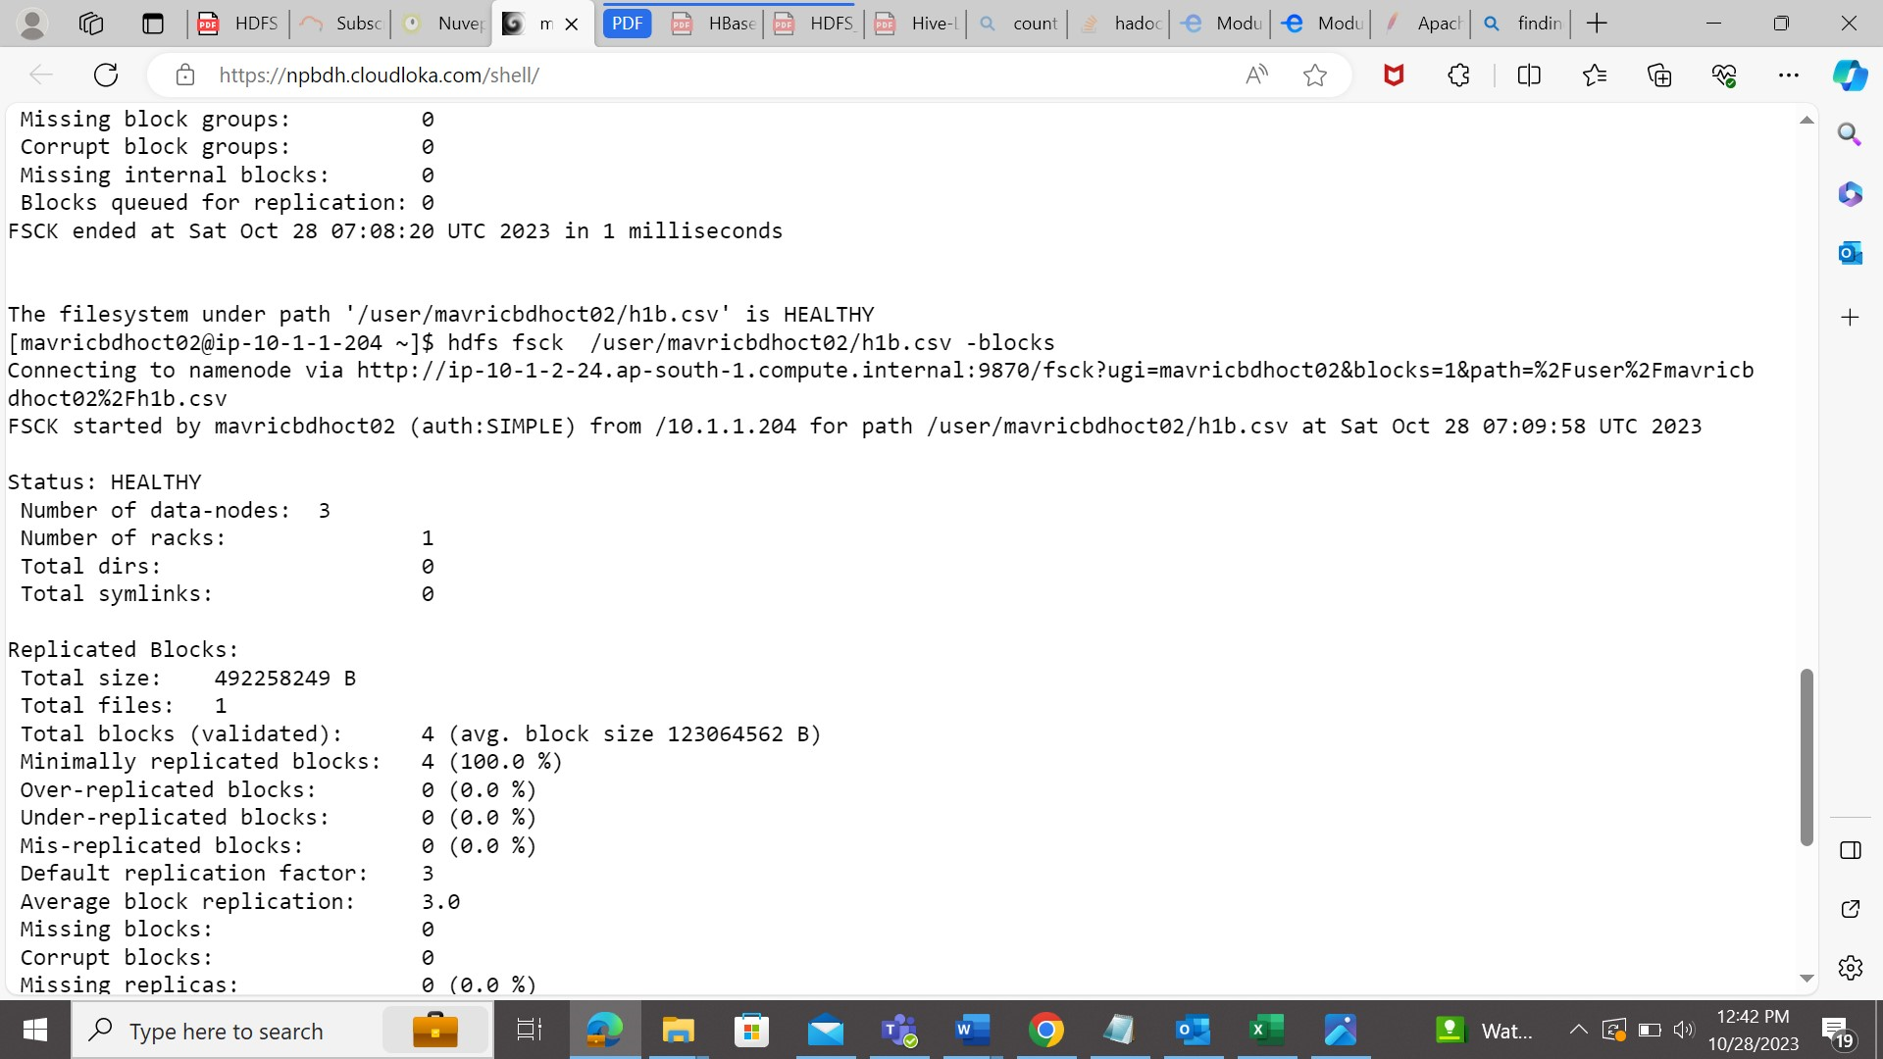

1. . **Move the h1b.csv file (in the HDFS) to the tickitdb folder in hdfs. How many blocks will be there for the tickitdb folder?**

hdfs dfs -mv h1b.csv tickitdb

hdfs dfs -ls tickitdb

hdfs fsck tickitdb

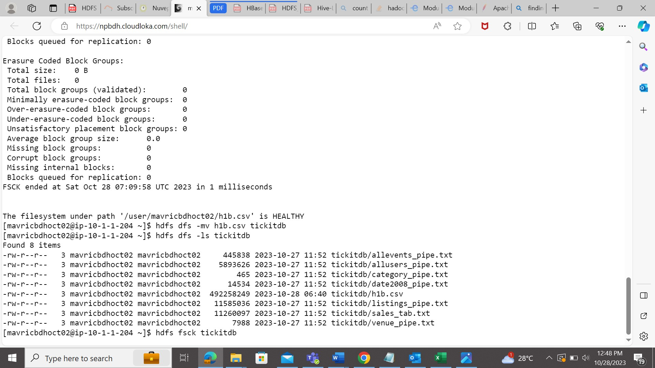

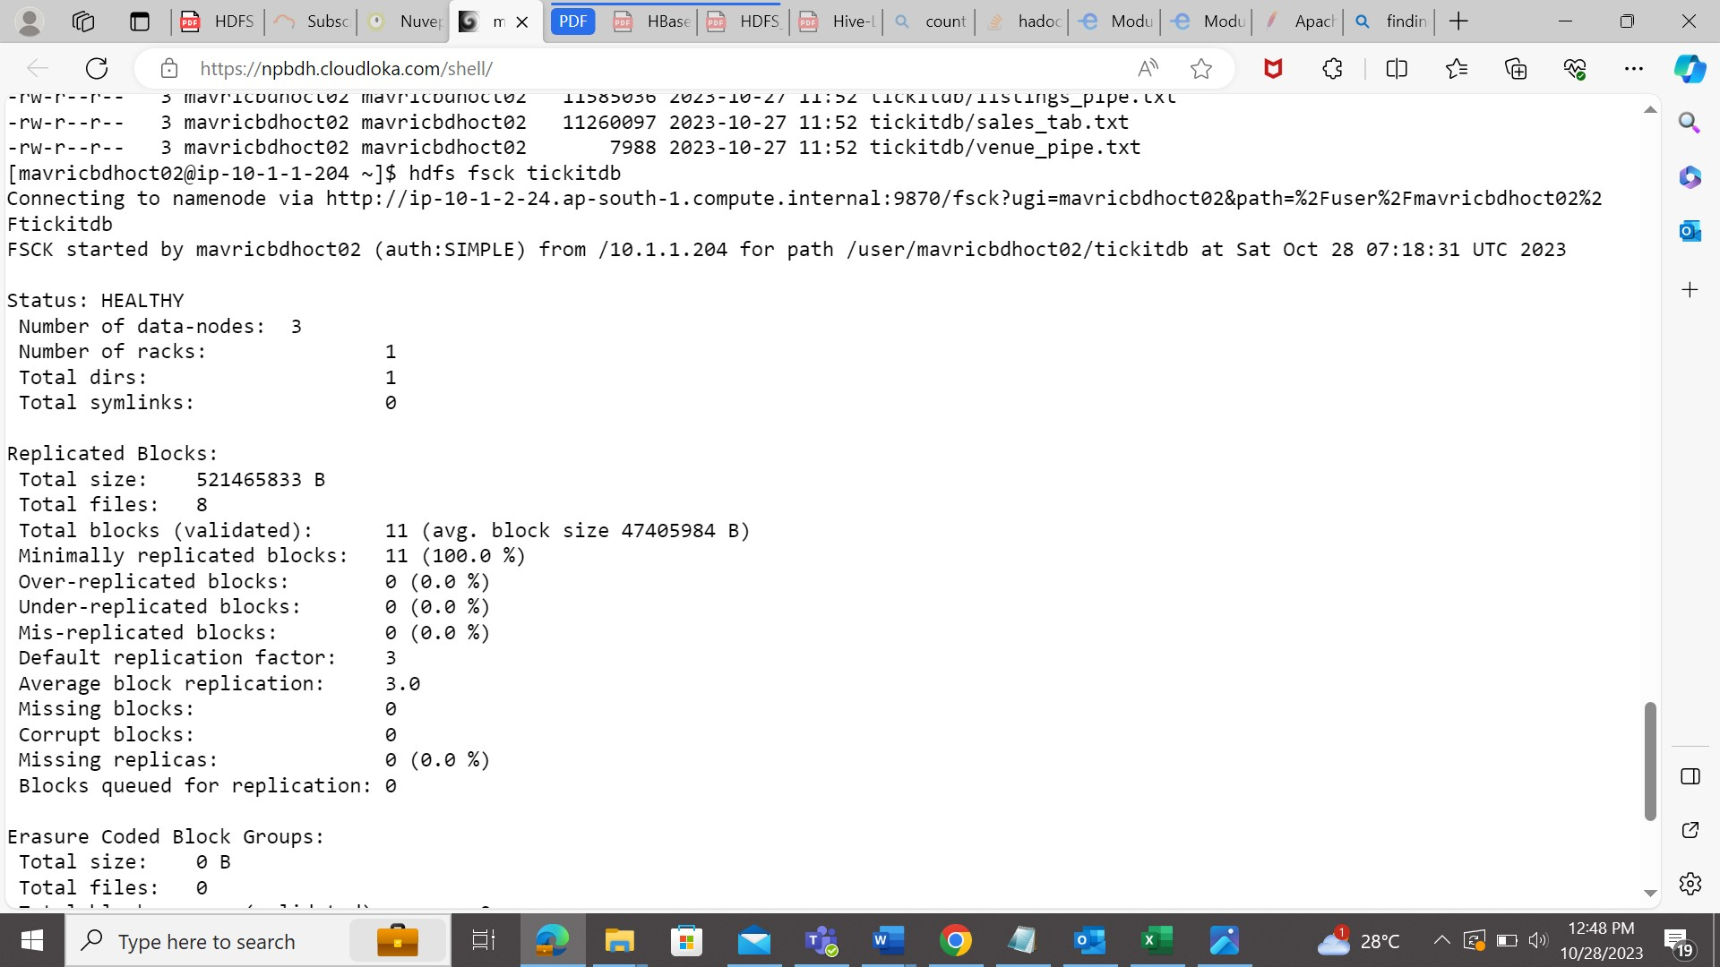

1. **Calculate the total storage space occupied by the files directory and its contents.**

hdfs dfs -du File.csv

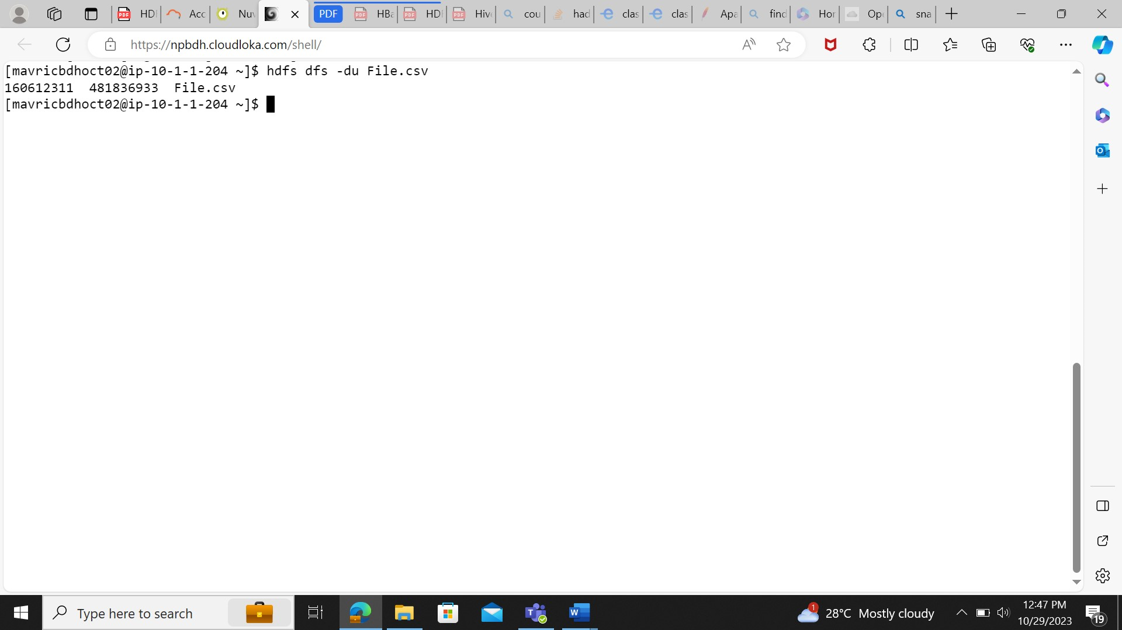

1. **Check the storage quota for the file directory.**

hdfs dfs -df File.csv

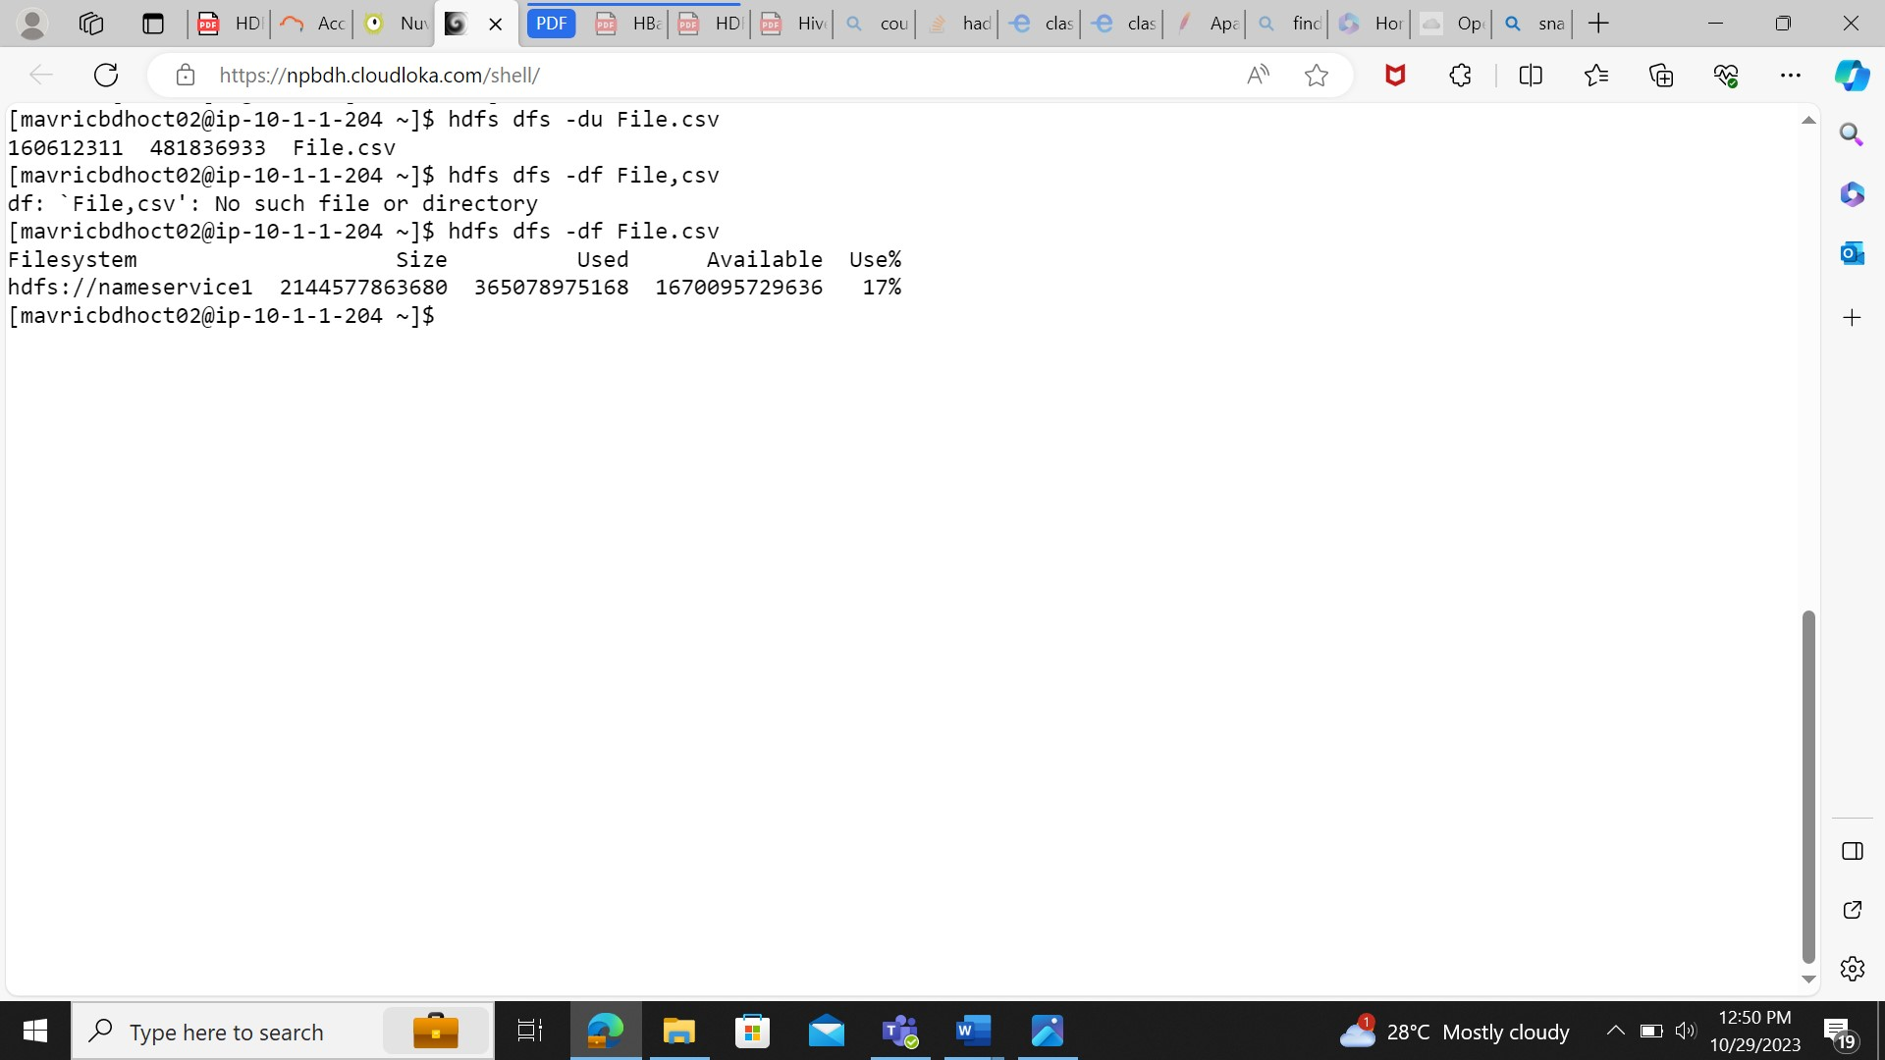

1. **Set a replication factor of 3 for all files within the file directory.**

hdfs dfs -setrep -w 3 file/File.csv

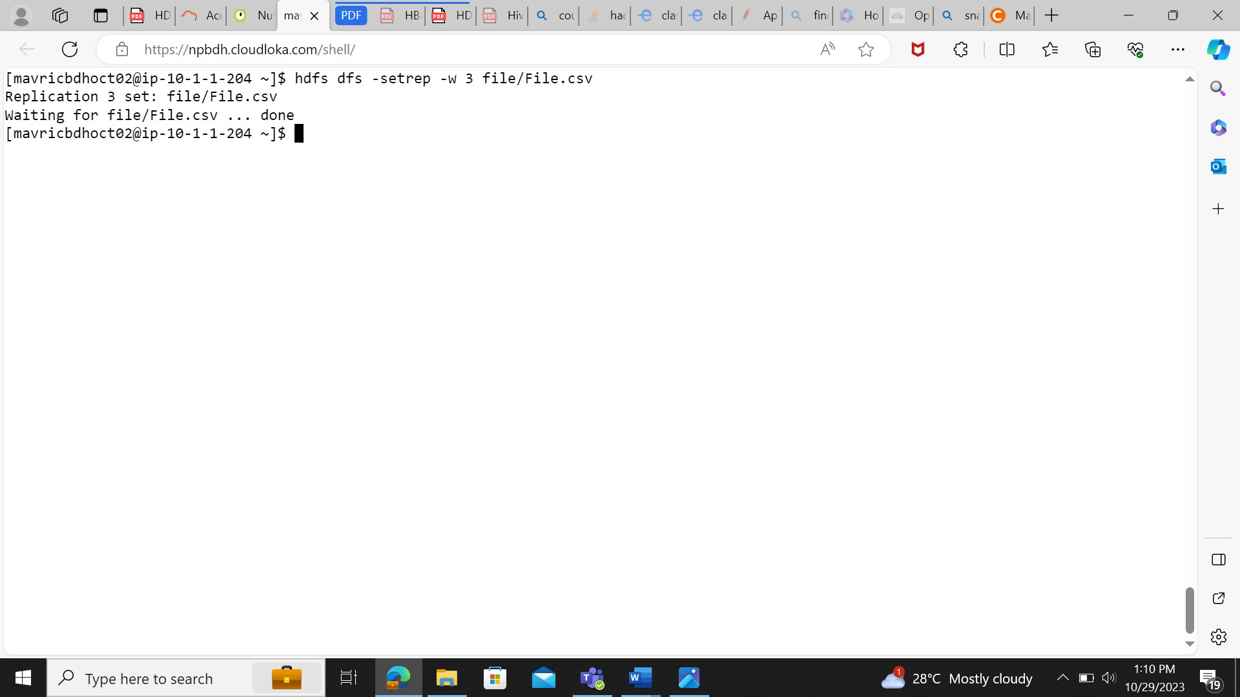

1. **Create an HDFS directory file names in your home directory and upload a local file 'test.txt' to it**

vi test.csv

[mavricbdhoct02@ip-10-1-1-204 ~]$ hdfs dfs -put test.csv fileNames

[mavricbdhoct02@ip-10-1-1-204 ~]$ hdfs dfs -ls fileNames

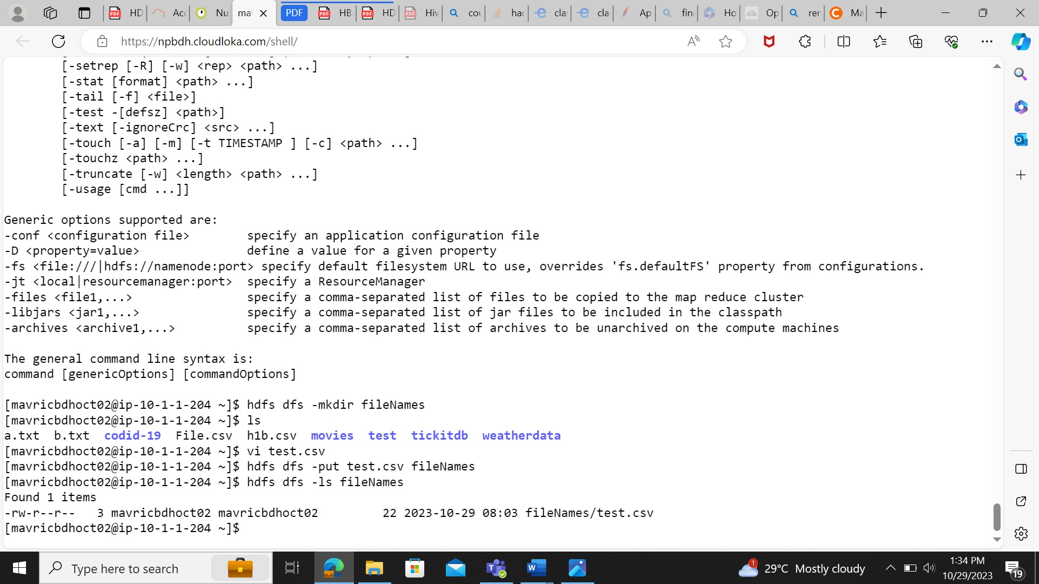

1. **List all the files and directories in the files directory in HDFS.**

hdfs dfs -ls fileNames



1. **Rename the 'file name' file to 'new file name' within the file directory in HDFS.**

hdfs dfs -mv fileNames newFileName

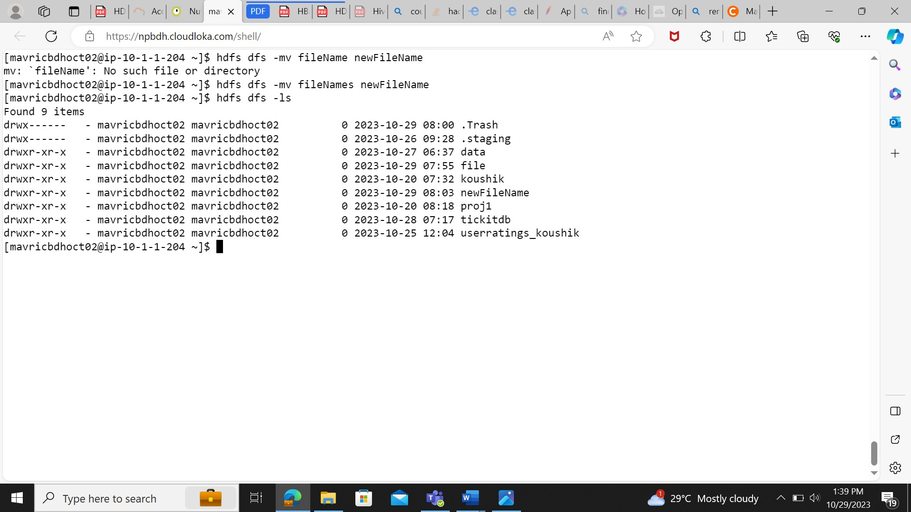

1. **Create a snapshot of the file directory in HDFS**

hdfs dfs -createSnapshot file snapshot1

hdfs dfsadmin -allowSnapshot file

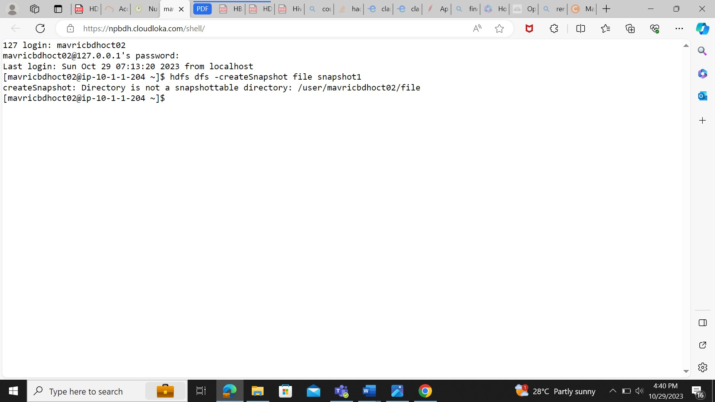

1. **Delete a specific snapshot 'snapshot1' from the file directory.**

hdfs dfs -deleteSnapshot file snapshot1

